- Bluebook Page105 May 2019 variant five task:

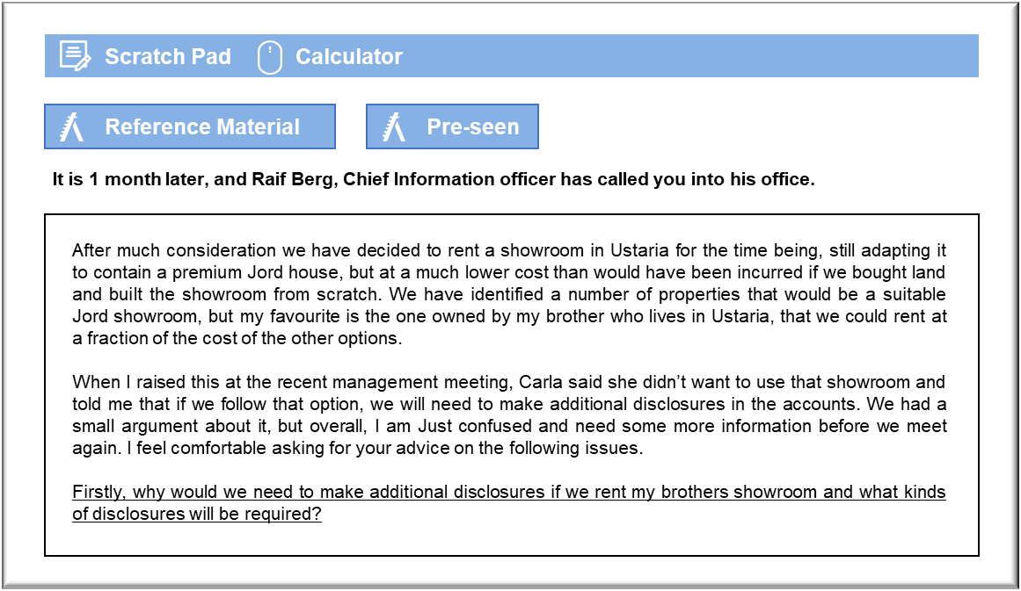MANAGEMENT CASE STUDY MAY 2019 EXAM ANSWERS

Variant5 Task3
These answers have been provided by CIMA for information purposes only. The answers created are indicative of a response that could be given by a good candidate. They are not to be considered exhaustive, and other appropriate relevant responses would receive credit.

CIMA will not accept challenges to these answers on the basis of academic judgement.

Need for additional disclosures and types of disclosures recommended
You might consider the application of IAS 24 Related Party Disclosures to this case. If
your brother is classed as a related person under IAS 24 then this arrangement will
have to be disclosed in the notes to the financial statements.
As CIO, you are a member of key management personnel. A close member of your
family would count as being a related party. The definition of “close member of the
family” does not actually include sibling relationships, focusing on children and
spouses. Your brother is probably not a related party under a narrow interpretation of
IAS 24, although if it could be argued that he could be expected to influence you then
he might be included in terms of the spirit of the standard.
It might be argued that the lack of a specific accounting regulation that requires
disclosure does not constitute grounds for omitting disclosures. From a purely ethical
perspective, the shareholders might be concerned by any lack of transparency in this
arrangement. The fact that your brother may have obtained an unfair advantage
without disclosure would probably constitute a material breach.
This matter is complicated still further by the fact that several family members hold
shares in the company. They will undoubtedly be aware of their brother’s ownership of
the showroom and so they would not require any disclosure. That may not be deemed
an acceptable excuse by the investment companies who have made major investments
in equity. They may feel that they have a right to know everything that the family
members do about the business.
Cultural differences
Culture, which is aptly defined by Hardy as ‘the way we do things around here’ is an
important part of the way in which an organisation works. Culture will influence
strategy formation and performance on an ongoing basis, therefore it is an important
part of success or failure and when an organisation begins to operate in a new culture it
is certainly worth taking time to understand that culture and how differences may
influence existing together.
In this scenario we are considering opening a showroom in Ustaria, where the culture
is relaxed, flexible and casual. This seems, superficially, to contrast with the culture at
Jord where work is performed on an efficient, formal, lean, well controlled ‘just-in?time’ basis. This could lead to frustrations for Jord if the staff working in the Ustaria
showroom don’t function in the style Jord is used to and depends upon to deliver its
high standards. For example, if a casual approach was to lead to delays in ordering,
Jord is likely to find this unacceptable, jeopardising high standards of customer service
and potentially affecting Jord’s reputation.
Worse still, if a casual approach leads to a reduced understanding of customer
requirements or mistakes in the order, Jord’s premium reputation may again suffer.
Managing the cultural differences
It seems unlikely that it would be acceptable to operate a showroom in Ustaria that has
a different culture to the rest of Jord’s global operations. Therefore, Jord will need to
attempt to influence the culture of those people working in its Ustaria showroom to be
more consistent with the culture at Jord.
It may be that Jord has to allow some element of difference in the way its Ustaria
showroom works to ensure the operation fits in satisfactorily in that country, but this is
more likely to be in the way of some small compromises rather than accepting a vastly
different operating culture.
Staff at the Ustaria showroom are likely to be used to working in certain ways,
consistent with the norms of Ustaria. Therefore, they will need to understand that the
way Jord likes to work is culturally different and receive good quality communication
about those differences and how Jord proposes the culture to operate in the Ustaria
Jord showroom.
Once staff in Ustaria understand why Jord operates in certain ways, and why it is
beneficial for the organisation overall, then there is a higher chance that they will be
receptive to work in that style themselves. Training will be required to ensure this is
fully understood and an open approach to communication with a two-way flow is
fundamental to setting this showroom up well.
Technology may be effectively utilised to communicate across national borders and
across different time zones. For example, a computer-based conference call may allow
people to talk in a virtually face-to-face manner regardless of the time difference.

